# Hello World RESTful Web Service

Program structure

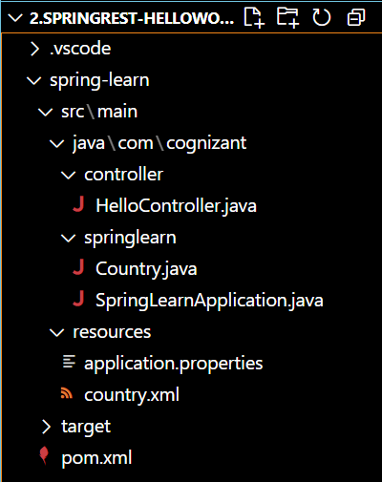

HelloController.java

package com.cognizant.springlearn.controller;

import org.slf4j.Logger;

import org.slf4j.LoggerFactory;

import org.springframework.web.bind.annotation.GetMapping;

import org.springframework.web.bind.annotation.RestController;

@RestController

public class HelloController {

    private static final Logger LOGGER = LoggerFactory.getLogger(HelloController.class);

    @GetMapping("/hello")

    public String sayHello() {

        LOGGER.debug("START: sayHello()");

        String message = "Hello World!!";

        LOGGER.debug("END: sayHello()");

        return message;

    }

}

Country.java

package com.cognizant.springlearn;

import org.slf4j.Logger;

import org.slf4j.LoggerFactory;

public class Country {

    private String code;

    private String name;

    private static final Logger LOGGER = LoggerFactory.getLogger(Country.class);

    public Country() {

        LOGGER.debug("Inside Country Constructor.");

    }

    public String getCode() {

        LOGGER.debug("Inside getCode()");

        return code;

    }

    public void setCode(String code) {

        LOGGER.debug("Inside setCode()");

        this.code = code;

    }

    public String getName() {

        LOGGER.debug("Inside getName()");

        return name;

    }

    public void setName(String name) {

        LOGGER.debug("Inside setName()");

        this.name = name;

    }

    @Override

    public String toString() {

        return "Country [code=" + code + ", name=" + name + "]";

    }

}

SpringLearnApplication.java

package com.cognizant.springlearn;

import org.springframework.boot.SpringApplication;

import org.springframework.boot.autoconfigure.SpringBootApplication;

@SpringBootApplication

public class SpringLearnApplication {

    public static void main(String[] args) {

        SpringApplication.run(SpringLearnApplication.class, args);

    }

}

country.xml

<?xml version="1.0" encoding="UTF-8"?>

<beans xmlns="http://www.springframework.org/schema/beans"

       xmlns:xsi="http://www.w3.org/2001/XMLSchema-instance"

       xsi:schemaLocation="http://www.springframework.org/schema/beans

       http://www.springframework.org/schema/beans/spring-beans.xsd">

    <bean id="country" class="com.cognizant.springlearn.Country">

        <property name="code" value="IN" />

        <property name="name" value="India" />

    </bean>

</beans>

pom.xml

<project xmlns="http://maven.apache.org/POM/4.0.0"

         xmlns:xsi="http://www.w3.org/2001/XMLSchema-instance"

         xsi:schemaLocation="http://maven.apache.org/POM/4.0.0

                             http://maven.apache.org/xsd/maven-4.0.0.xsd">

    <modelVersion>4.0.0</modelVersion>

    <groupId>com.cognizant</groupId>

    <artifactId>spring-learn</artifactId>

    <version>0.0.1-SNAPSHOT</version>

    <properties>

        <java.version>17</java.version>

    </properties>

    <dependencies>

        <!-- Spring Context for XML configuration -->

        <dependency>

            <groupId>org.springframework</groupId>

            <artifactId>spring-context</artifactId>

            <version>5.3.34</version>

        </dependency>

        <!-- ✅ REST API support -->

        <dependency>

            <groupId>org.springframework.boot</groupId>

            <artifactId>spring-boot-starter-web</artifactId>

            <version>2.7.18</version>

        </dependency>

        <!-- SLF4J Logging API -->

        <dependency>

            <groupId>org.slf4j</groupId>

            <artifactId>slf4j-api</artifactId>

            <version>2.0.13</version>

        </dependency>

        <!-- SLF4J Simple Binding -->

        <dependency>

            <groupId>org.slf4j</groupId>

            <artifactId>slf4j-simple</artifactId>

            <version>2.0.13</version>

        </dependency>

    </dependencies>

    <build>

        <plugins>

            <!-- Compile Plugin -->

            <plugin>

                <groupId>org.apache.maven.plugins</groupId>

                <artifactId>maven-compiler-plugin</artifactId>

                <version>3.11.0</version>

                <configuration>

                    <source>${java.version}</source>

                    <target>${java.version}</target>

                </configuration>

            </plugin>

            <!-- ✅ Spring Boot Plugin to support `spring-boot:run` -->

            <plugin>

                <groupId>org.springframework.boot</groupId>

                <artifactId>spring-boot-maven-plugin</artifactId>

                <version>2.7.18</version>

            </plugin>

            <!-- Optional Exec plugin to run main class directly -->

            <plugin>

                <groupId>org.codehaus.mojo</groupId>

                <artifactId>exec-maven-plugin</artifactId>

                <version>3.1.0</version>

                <configuration>

                    <mainClass>com.cognizant.springlearn.SpringLearnApplication</mainClass>

                </configuration>

            </plugin>

        </plugins>

    </build>

</project>

Output:



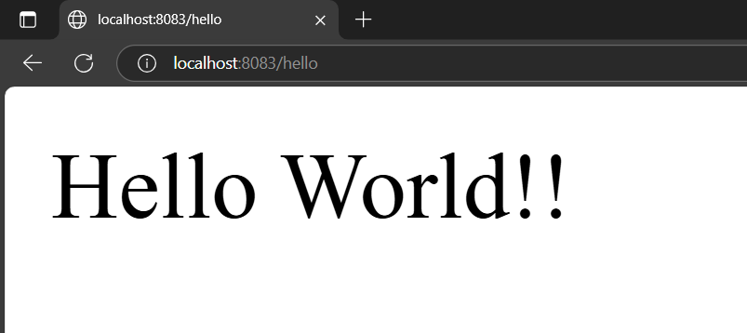

# REST - Country Web Service

Program structure

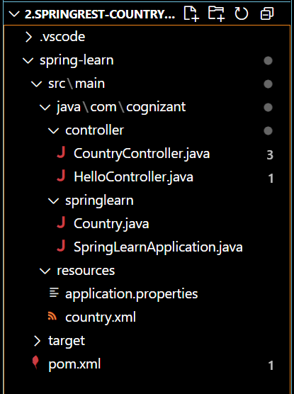

CountryController.java

package com.cognizant.springlearn.controller;

import org.slf4j.Logger;

import org.slf4j.LoggerFactory;

import org.springframework.context.ApplicationContext;

import org.springframework.context.support.ClassPathXmlApplicationContext;

import org.springframework.web.bind.annotation.RequestMapping;

import org.springframework.web.bind.annotation.RestController;

import com.cognizant.springlearn.Country;

@RestController

public class CountryController {

    private static final Logger LOGGER = LoggerFactory.getLogger(CountryController.class);

    @RequestMapping("/country")

    public Country getCountryIndia() {

        LOGGER.debug("START: getCountryIndia()");

        ApplicationContext context = new ClassPathXmlApplicationContext("country.xml");

        Country country = (Country) context.getBean("country", Country.class);

        LOGGER.debug("Country : {}", country.toString());

        LOGGER.debug("END: getCountryIndia()");

        return country;

    }

}

HelloController.java

package com.cognizant.springlearn.controller;

import org.slf4j.Logger;

import org.slf4j.LoggerFactory;

import org.springframework.web.bind.annotation.GetMapping;

import org.springframework.web.bind.annotation.RestController;

@RestController

public class HelloController {

    private static final Logger LOGGER = LoggerFactory.getLogger(HelloController.class);

    @GetMapping("/hello")

    public String sayHello() {

        LOGGER.debug("START: sayHello()");

        String message = "Hello World!!";

        LOGGER.debug("END: sayHello()");

        return message;

    }

}

Country.java

package com.cognizant.springlearn;

import org.slf4j.Logger;

import org.slf4j.LoggerFactory;

public class Country {

    private static final Logger LOGGER = LoggerFactory.getLogger(Country.class);

    private String code;

    private String name;

    public Country() {

        LOGGER.debug("Inside Country Constructor.");

    }

    public String getCode() {

        LOGGER.debug("Inside getCode()");

        return code;

    }

    public void setCode(String code) {

        LOGGER.debug("Inside setCode()");

        this.code = code;

    }

    public String getName() {

        LOGGER.debug("Inside getName()");

        return name;

    }

    public void setName(String name) {

        LOGGER.debug("Inside setName()");

        this.name = name;

    }

    @Override

    public String toString() {

        return "Country [code=" + code + ", name=" + name + "]";

    }

}

SpringLearnApplication.java

package com.cognizant.springlearn;

import org.springframework.boot.SpringApplication;

import org.springframework.boot.autoconfigure.SpringBootApplication;

@SpringBootApplication

public class SpringLearnApplication {

    public static void main(String[] args) {

        SpringApplication.run(SpringLearnApplication.class, args);

    }

}

country.xml

<?xml version="1.0" encoding="UTF-8"?>

<beans xmlns="http://www.springframework.org/schema/beans"

       xmlns:xsi="http://www.w3.org/2001/XMLSchema-instance"

       xsi:schemaLocation="http://www.springframework.org/schema/beans

       https://www.springframework.org/schema/beans/spring-beans.xsd">

    <bean id="country" class="com.cognizant.springlearn.Country">

        <property name="code" value="IN"/>

        <property name="name" value="India"/>

    </bean>

</beans>

pom.xml

<project xmlns="http://maven.apache.org/POM/4.0.0"

         xmlns:xsi="http://www.w3.org/2001/XMLSchema-instance"

         xsi:schemaLocation="http://maven.apache.org/POM/4.0.0

                             http://maven.apache.org/xsd/maven-4.0.0.xsd">

    <modelVersion>4.0.0</modelVersion>

    <groupId>com.cognizant</groupId>

    <artifactId>spring-learn</artifactId>

    <version>0.0.1-SNAPSHOT</version>

    <properties>

        <java.version>17</java.version>

    </properties>

    <dependencies>

        <!-- Spring Context for XML configuration -->

        <dependency>

            <groupId>org.springframework</groupId>

            <artifactId>spring-context</artifactId>

            <version>5.3.34</version>

        </dependency>

        <!-- ✅ REST API support -->

        <dependency>

            <groupId>org.springframework.boot</groupId>

            <artifactId>spring-boot-starter-web</artifactId>

            <version>2.7.18</version>

        </dependency>

        <!-- SLF4J Logging API -->

        <dependency>

            <groupId>org.slf4j</groupId>

            <artifactId>slf4j-api</artifactId>

            <version>2.0.13</version>

        </dependency>

        <!-- SLF4J Simple Binding -->

        <dependency>

            <groupId>org.slf4j</groupId>

            <artifactId>slf4j-simple</artifactId>

            <version>2.0.13</version>

        </dependency>

    </dependencies>

    <build>

        <plugins>

            <!-- Compile Plugin -->

            <plugin>

                <groupId>org.apache.maven.plugins</groupId>

                <artifactId>maven-compiler-plugin</artifactId>

                <version>3.11.0</version>

                <configuration>

                    <source>${java.version}</source>

                    <target>${java.version}</target>

                </configuration>

            </plugin>

            <!-- ✅ Spring Boot Plugin to support `spring-boot:run` -->

            <plugin>

                <groupId>org.springframework.boot</groupId>

                <artifactId>spring-boot-maven-plugin</artifactId>

                <version>2.7.18</version>

            </plugin>

            <!-- Optional Exec plugin to run main class directly -->

            <plugin>

                <groupId>org.codehaus.mojo</groupId>

                <artifactId>exec-maven-plugin</artifactId>

                <version>3.1.0</version>

                <configuration>

                    <mainClass>com.cognizant.springlearn.SpringLearnApplication</mainClass>

                </configuration>

            </plugin>

        </plugins>

    </build>

</project>

Output:



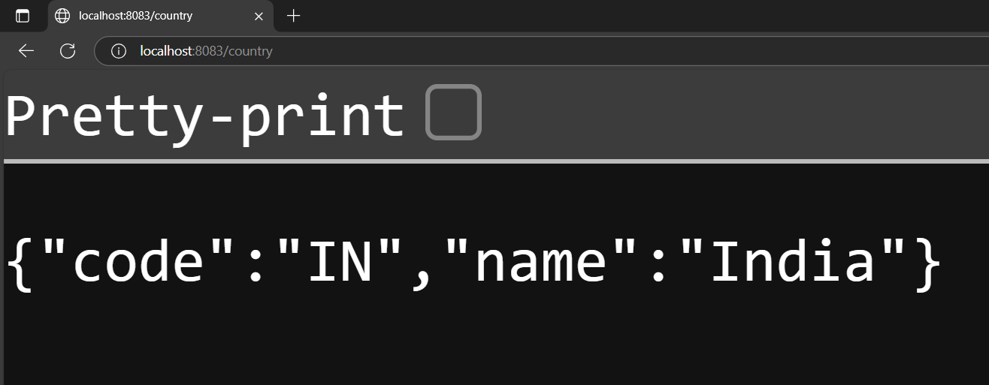

# REST - Get country based on country code

Program structure

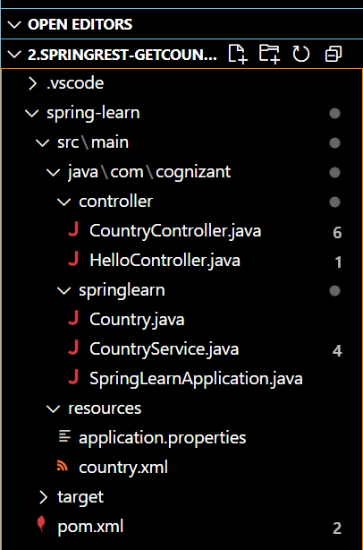

CountryController.java

package com.cognizant.springlearn.controller;

import org.springframework.web.bind.annotation.GetMapping;

import org.springframework.web.bind.annotation.PathVariable;

import org.springframework.web.bind.annotation.RestController;

import com.cognizant.springlearn.Country;

import com.cognizant.springlearn.service.CountryService;

@RestController

public class CountryController {

    @GetMapping("/country/{code}")

    public Country getCountry(@PathVariable String code) {

        CountryService countryService = new CountryService();

        return countryService.getCountry(code);

    }

}

Country.java

package com.cognizant.springlearn;

import org.slf4j.Logger;

import org.slf4j.LoggerFactory;

public class Country {

    private static final Logger LOGGER = LoggerFactory.getLogger(Country.class);

    private String code;

    private String name;

    public Country() {

        LOGGER.debug("Inside Country Constructor.");

    }

    public String getCode() {

        LOGGER.debug("Inside getCode()");

        return code;

    }

    public void setCode(String code) {

        LOGGER.debug("Inside setCode()");

        this.code = code;

    }

    public String getName() {

        LOGGER.debug("Inside getName()");

        return name;

    }

    public void setName(String name) {

        LOGGER.debug("Inside setName()");

        this.name = name;

    }

    @Override

    public String toString() {

        return "Country [code=" + code + ", name=" + name + "]";

    }

}

CountryService.java

package com.cognizant.springlearn.service;

import java.util.List;

import org.springframework.context.ApplicationContext;

import org.springframework.context.support.ClassPathXmlApplicationContext;

import com.cognizant.springlearn.Country;

public class CountryService {

    public Country getCountry(String code) {

        ApplicationContext context = new ClassPathXmlApplicationContext("country.xml");

        List<Country> countryList = context.getBean("countryList", List.class);

        return countryList.stream()

            .filter(c -> c.getCode().equalsIgnoreCase(code))

            .findFirst()

            .orElse(null);

    }

}

SpringLearnApplication.java

package com.cognizant.springlearn;

import org.springframework.boot.SpringApplication;

import org.springframework.boot.autoconfigure.SpringBootApplication;

@SpringBootApplication

public class SpringLearnApplication {

    public static void main(String[] args) {

        SpringApplication.run(SpringLearnApplication.class, args);

    }

}

country.xml

<?xml version="1.0" encoding="UTF-8"?>

<beans xmlns="http://www.springframework.org/schema/beans"

       xmlns:xsi="http://www.w3.org/2001/XMLSchema-instance"

       xsi:schemaLocation="http://www.springframework.org/schema/beans

       https://www.springframework.org/schema/beans/spring-beans.xsd">

    <bean id="countryList" class="java.util.ArrayList">

        <constructor-arg>

            <list>

                <bean class="com.cognizant.springlearn.Country">

                    <property name="code" value="IN"/>

                    <property name="name" value="India"/>

                </bean>

                <bean class="com.cognizant.springlearn.Country">

                    <property name="code" value="US"/>

                    <property name="name" value="United States"/>

                </bean>

                <bean class="com.cognizant.springlearn.Country">

                    <property name="code" value="DE"/>

                    <property name="name" value="Germany"/>

                </bean>

                <bean class="com.cognizant.springlearn.Country">

                    <property name="code" value="JP"/>

                    <property name="name" value="Japan"/>

                </bean>

            </list>

        </constructor-arg>

    </bean>

</beans>

pom.xml

<project xmlns="http://maven.apache.org/POM/4.0.0"

         xmlns:xsi="http://www.w3.org/2001/XMLSchema-instance"

         xsi:schemaLocation="http://maven.apache.org/POM/4.0.0

                             http://maven.apache.org/xsd/maven-4.0.0.xsd">

    <modelVersion>4.0.0</modelVersion>

    <groupId>com.cognizant</groupId>

    <artifactId>spring-learn</artifactId>

    <version>0.0.1-SNAPSHOT</version>

    <packaging>jar</packaging>

    <name>spring-learn</name>

    <description>Spring Learn REST API</description>

    <!-- ✅ Correct parent with version defined -->

    <parent>

        <groupId>org.springframework.boot</groupId>

        <artifactId>spring-boot-starter-parent</artifactId>

        <version>3.2.5</version>

        <relativePath/> <!-- lookup parent from repository -->

    </parent>

    <properties>

        <java.version>17</java.version>

    </properties>

    <dependencies>

        <!-- ✅ Core Spring Web for REST controllers -->

        <dependency>

            <groupId>org.springframework.boot</groupId>

            <artifactId>spring-boot-starter-web</artifactId>

        </dependency>

        <!-- ✅ Spring Context for XML-based bean loading -->

        <dependency>

            <groupId>org.springframework</groupId>

            <artifactId>spring-context</artifactId>

        </dependency>

        <!-- ✅ For logging with SLF4J and Logback -->

        <dependency>

            <groupId>org.springframework.boot</groupId>

            <artifactId>spring-boot-starter-logging</artifactId>

        </dependency>

        <!-- ✅ Optional: Spring Boot DevTools for live reload -->

        <dependency>

            <groupId>org.springframework.boot</groupId>

            <artifactId>spring-boot-devtools</artifactId>

            <scope>runtime</scope>

            <optional>true</optional>

        </dependency>

        <!-- ✅ Optional: For unit testing -->

        <dependency>

            <groupId>org.springframework.boot</groupId>

            <artifactId>spring-boot-starter-test</artifactId>

            <scope>test</scope>

        </dependency>

    </dependencies>

    <build>

        <plugins>

            <!-- ✅ Required to enable spring-boot:run command -->

            <plugin>

                <groupId>org.springframework.boot</groupId>

                <artifactId>spring-boot-maven-plugin</artifactId>

            </plugin>

        </plugins>

    </build>

</project>

